Tourism Agency ERP System
Enterprise Software Design and Architecture
Milestone 2: System Modeling

- Component Diagram

The diagram for the Tourism Agency ERP System, which is also known as TAES shows how everything is connected. On the side we have the client layer and the API Gateway. These are connected to six microservices in the middle. The Tourism Agency ERP System has microservices for the User, Tour, Booking, CRM, Staff and Notification. These microservices for the Tourism Agency ERP System are connected to the backend database clusters on the side. The Tourism Agency ERP System also has a layer at the bottom right for connecting to other services, like payment, travel and communication APIs.
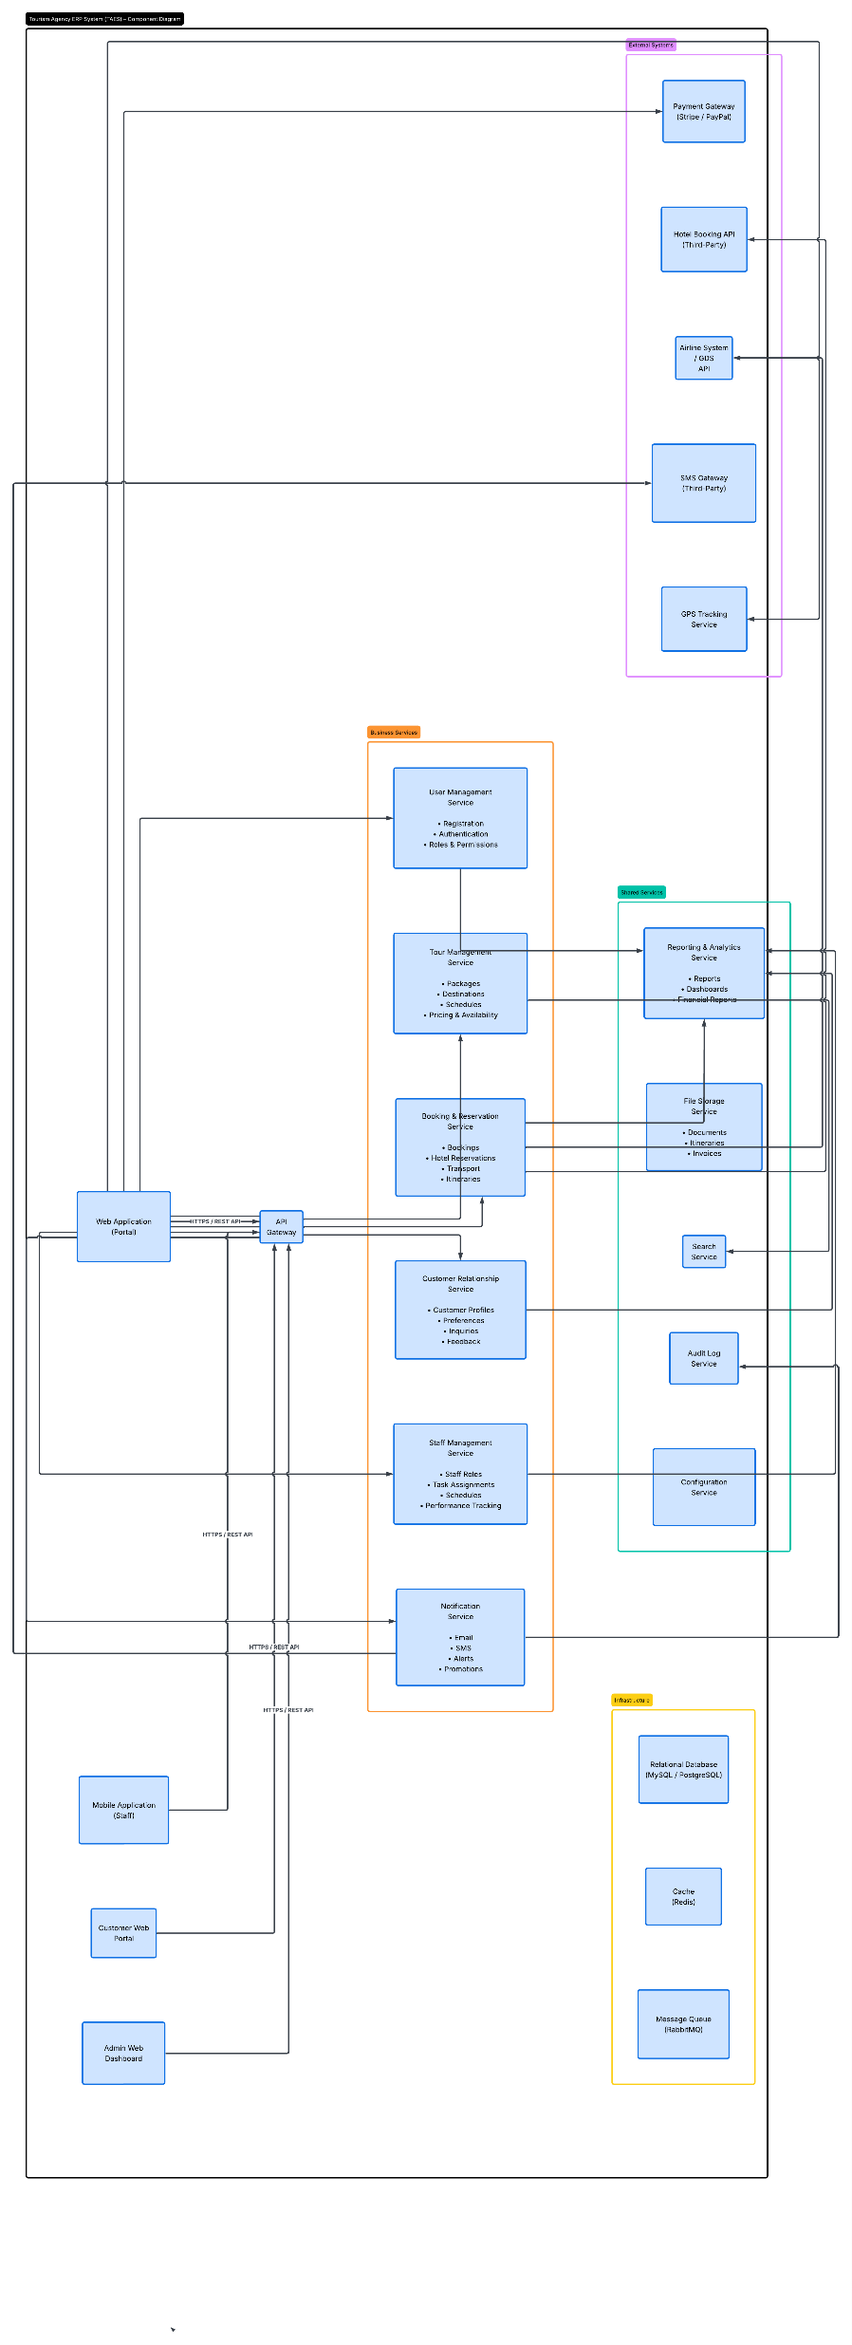

- Sequence Diagram:

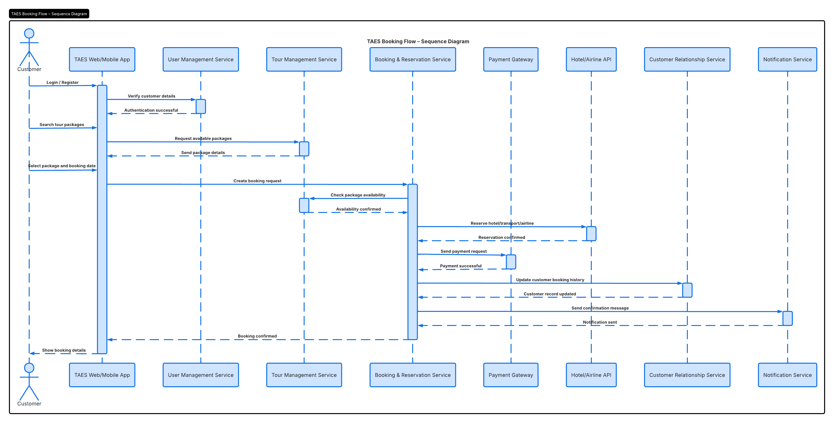

The UML Sequence Diagram for the Booking Flow, in the Tourism Agency ERP System (TAES) shows how the web or mobile app works with six microservices.
These microservices are User, Tour, Booking, CRM, Staff and Notification.
The diagram also shows how the app works with third-party APIs.
It maps out the travel transaction process from when a customer logs in to when they get their final confirmation.
The process involves the web or mobile app coordinating with these microservices and APIs.
The Tourism Agency ERP System (TAES) uses this diagram to plan and visualize the booking flow
The sequence diagram helps to ensure a customer experience.
It covers the transaction process in chronological order.

- Use Case Diagram:

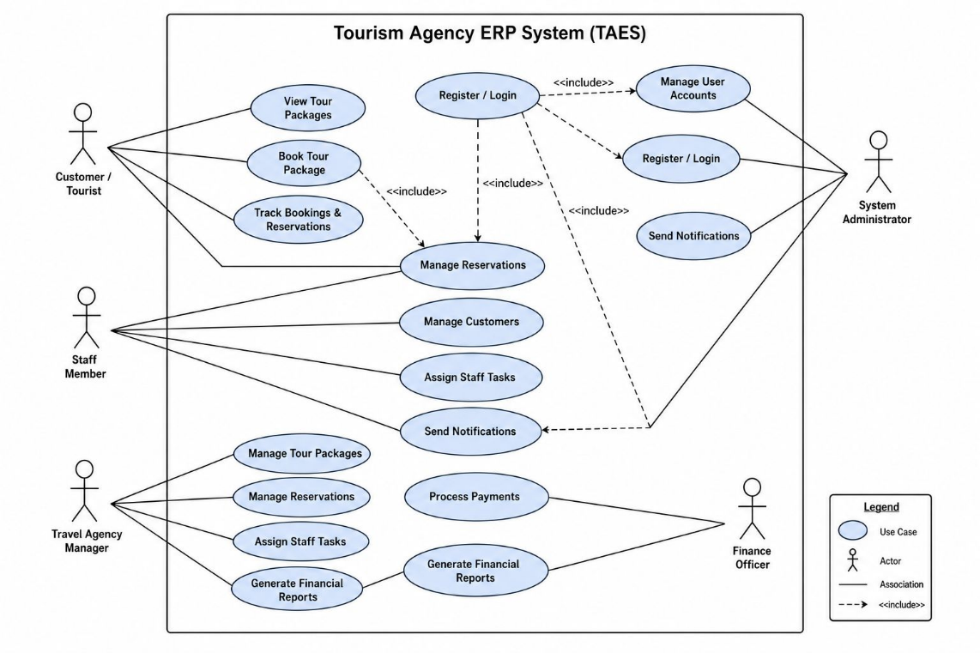

The UML Use Case Diagram for the Tourism Agency ERP System is like a map that shows how the Tourism Agency ERP System works. It looks at how five different kinds of people use the Tourism Agency ERP System. These people are Customers, Staff Members, Travel Agency Managers, Finance Officers and System Administrators. The Tourism Agency ERP System has some parts like user authentication, booking reservations, financial reporting and automated notifications. These five roles interact with these parts of the Tourism Agency ERP System in ways. The Tourism Agency ERP System is defined by how these people and parts work. The Tourism Agency ERP System has boundaries and the UML Use Case Diagram for the Tourism Agency ERP System shows what is inside and, outside of these boundaries.

- Deployment Diagram:

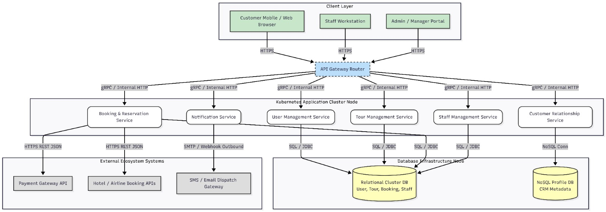

The Deployment Architecture Diagram for the Tourism Agency ERP System (TAES) shows how client devices connect to a Kubernetes cluster.
This cluster hosts six microservices.
These microservices link to databases, including relational and NoSQL types.
They also connect to APIs for travel, payment and notifications.
The Tourism Agency ERP System (TAES) relies on these connections, for its operations.
The client device layer is a part of the Tourism Agency ERP System (TAES) setup.

Development Group no.33
J A G D Perera- PS/2022/102 (Group Leader)
A V D Mendis-PS/2022/169
A P D C Pathirana-PS/2022/173
U K R Bhagya- PS/2022/229

